- Each person attending will receive table space, a gift, door prize tickets & plenty to eat.
- Random prizes will be awarded throughout the event
- A great time of socializing with other scrap bookers/crafters
- We’ll be challenged with devotionals during the retreat
- A great opportunity to share your photos and scrapbooking skills
Event Perks

Ladies Spiritual Scrapbooking & Craft Weekend

Get-Away

at

Camp Mantowagan

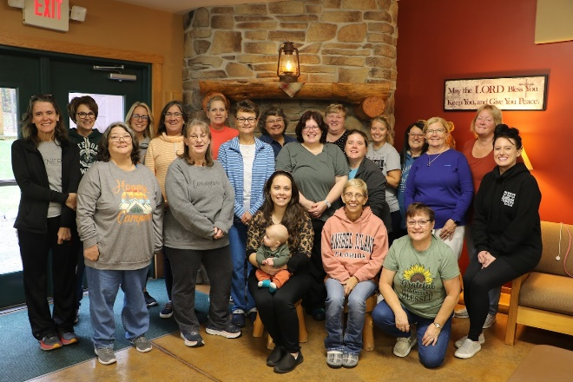

The 2023 Group

October 11 -13, 2024

The 2016 group.

Camp Mantowagan is located at 2671 Camp Lane, Saxton, PA
There are directions at the camp web site: www.campmantowagan.com

ho w to customize
Scrapbooking/Crafters Get Away
You are invited to attend the Camp Mantowagan sixteenth women’s spiritual and scrapbooking & craft weekend get-a-way. This event is a fundraiser for the camp. This is also a great way for you to get together with your friends. We have a lot planned and we need you there to make it a success.
Notice that we’ve added “craft” to our event. I’ve had ladies express interest in attending, but don’t scrapbook. Let’s try opening this up to anyone that has a craft they’d like to work on during our weekend.

Dates and Times:
Friday, October 11
4:00 p.m. until Sunday,
October 13 about 2:00 p.m.

Event Highlights
- Friday night we will be having ham barbecue & pasta salad upon your arrival & late night snacks.
- Saturday continental breakfast, lunch will be our traditional soup and sandwiches, dinner will be lasagna & salad Saturday night & late night snacks.
- Sunday morning we will serve a continental breakfast and have leftovers for lunch.
- Snacks, iced tea and lemonade will be provided throughout the entire event
- These menus are subject to change

Retreat Price
The cost of the event is $135 per person. All fees will go to Camp Mantowagan.

“Other” Pricing

- Following are the prices if you cannot attend the whole time
- Friday only—$30
- Saturday only—$65
- Friday & Saturday only—$95

Name ____________________________

Address___________________________
____________________________
Phone ____________________________
E-mail ____________________________

Names of all people in your group
___________________________________________________________________________________________________________________________
______________________________________________________________
Please complete the registration and mail it with your check made payable to Camp Mantowagan by October 4, 2024

Mail it to:
Linda Johnson
200 Pennway Drive
Nanty Glo, PA 15943
LJohn7478@gmail.com
Phone 814-242-1063 (call or text) or you can reach out to me via Facebook or on Facebook Messenger

Company Name
Street Address
Address 2
City, ST ZIP Code
Phone (555)555-0125
Fax (555)555-0145
Web site address

